

**American International University-Bangladesh (AIUB)**  
 Department of Computer Science

Faculty of Science & Technology (FST)

**AirLink 360 – Smart Airline Passenger Assistance Platform**

**Semester: Fall 25-26**

|  |  |  |
| --- | --- | --- |
| ***Group:3*** | | ***Section: M*** |
| **SL** | **Student Name** | **Student ID** |
| 1 | MD. Tanzimul Islam | 23-53486-3 |
| 2 | Safiul Alam | 23-53543-3 |
| 3 | Fariha Nower Raisa | 23-54082-3 |
| 4 | Israt Jahan Singdha | 23-54089-3 |
| 5 | Arfanul Hoque Nehal | 23-54270-3 |

Table of Contents

1. Project Proposal xx

1.1 Background to the Problem xx

1.2 Selection of Process Model xx

2. Software Requirements Specification (SRS) / PRD xx

2.1 Scopes and Features xx

2.2 User Story Table xx

2.3 Requirements Traceability Matrix xx

2.3.1 Functional Requirements xx

2.3.2 Non-Functional Requirements xx

3. Software Design xx

3.1 System Deisgn xx

3.2 UI Deisgn using Figma xx

4. Git Workflow xx

5. Software Testing xx

6. Conclusion xx

**1. PROJECT PROPOSAL**



* 1. **Background to the Problem**

In today’s fast-paced aviation industry, passengers often face multiple challenges during their travel experience — from ticket booking complications and last-minute schedule changes to difficulty finding real-time flight information or accessing customer service efficiently. Airlines are also struggling to maintain effective communication with passengers and ensure a seamless experience across different stages of air travel.

Traditional systems used by airlines rely heavily on fragmented information channels, making it difficult for passengers to receive real-time updates about flight delays, gate changes, baggage status, or in-flight services. This results in frustration, missed flights, and negative customer experiences. Additionally, airlines often lack centralized tools to analyze customer needs and feedback effectively.

With the advancement of Artificial Intelligence (AI) and cloud-based technologies, there is a growing opportunity to automate and simplify these processes. A smart and integrated system can provide passengers with real-time assistance, personalized notifications, and digital support at every stage of their journey — from ticket purchase to arrival.

The AirLink 360 project aims to address these challenges by developing an intelligent airline passenger assistance platform that bridges the communication gap between passengers and airlines. The system will provide smart services such as flight tracking, check-in support, baggage updates, emergency alerts, and AI-driven chat assistance, ensuring a smoother and more connected travel experience.

* 1. **Selection of Process Model**

## We have adopted the Agile Scrum methodology with modular incremental development for this project due to the following factors :

## Multi-Role Complexity: The system serves 7 distinct user groups, each requiring tailored functionalities. Scrum allows us to develop, test, and refine each user module incrementally, adhering to the incremental development model (L02).

## Clear Yet Evolving Requirements: While core functional requirements are well-defined (SRS, user stories), the integration of AI, real-time APIs, and security standards necessitates flexibility. Scrum’s iterative cycles enable continuous feedback and adaptation, addressing requirements engineering challenges (L03).

## High Integration Demands: The project involves multiple external integrations (payment gateways, airline APIs, travel agency systems). Scrum facilitates early and frequent integration testing, reducing late-stage risks, as emphasized in risk management (L12).

## Collaborative Team Structure: With a 5-member cross-functional team, Scrum promotes daily coordination, transparent progress tracking, and collective ownership of deliverables, supporting human factors in agile development (L04).

## Scrum Framework Implementation (SCRUM)

## Team Structure & Roles

## Scrum Master: Responsible for ensuring adherence to Scrum practices, removing impediments, and facilitating ceremonies.

## Product Owner: Manages the Product Backlog, prioritizes requirements, and represents stakeholder interests.

## Scrum Team: 5-member development team with cross-functional skills (frontend, backend, AI, database, QA).

## Customer/Stakeholders: Includes airline representatives, airport authorities, and travel agencies who provide feedback during Sprint Reviews.

## Management: Provides resources, sets strategic goals, and participates in key decision-making.

## Scrum Phases

## Pre-game Phase:

## Planning: Create and prioritize the Product Backlog based on user stories and functional requirements.

## Architecture: Design high-level system architecture and review for feasibility.

## Development (Game) Phase:

## Conduct Sprints (2–4 weeks each) where each Sprint delivers a potentially shippable product increment.

## Use Sprint Backlog to track tasks for the current Sprint.

## Hold Daily Scrum meetings (15 minutes) to synchronize and identify blockers.

## End each Sprint with a Sprint Review (demo) and Sprint Retrospective (process improvement).

## Post-game Phase:

## Final integration, system testing, documentation, and release preparation.

## Key Scrum Practices for AirLink 360

## Product Backlog Management

## Continuously prioritized list of user stories, bugs, and technical tasks derived from SRS.

## Maintained by the Product Owner with input from stakeholders.

## Sprint Planning Meetings

## Two-part meeting:

## Part 1: Select backlog items for the Sprint based on priority and team capacity.

## Part 2: Break down items into tasks and create the Sprint Backlog.

## Daily Scrum Meetings

## 15-minute stand-ups to answer:

## What did I do yesterday?

## What will I do today?

## What impediments do I face?

## Sprint Reviews

## Demo of completed features to stakeholders at the end of each Sprint.

## Informal feedback session to validate deliverables and adjust priorities.

## Sprint Retrospectives

## Team reflection on processes, tools, and collaboration.

## Actionable improvements identified for the next Sprint.

## Timeboxing

## Sprints are fixed at 2–4 weeks to maintain focus and predictability.

## Scope is adjusted to fit the timebox, not the other way around.

## Definition of Done (DoD)

## Clear criteria for each user story:

## Code written, reviewed, and merged.

## Unit and integration tests passed.

## Documentation updated.

## Product Owner acceptance.

## Expected Outcomes from Scrum Implementation

## Incremental Delivery of Working Software

## A potentially shippable product increment delivered every 2–4 weeks.

## Early availability of core features (e.g., passenger booking by Sprint 4).

## Enhanced Stakeholder Engagement

## Regular feedback loops via Sprint Reviews ensure alignment with user needs.

## Reduced risk of late-stage requirement changes.

## Improved Team Collaboration & Transparency

## Daily Scrums and visible task boards (e.g., Jira/Trello) keep everyone aligned.

## Cross-functional teamwork reduces silos and improves problem-solving.

## Early Risk Identification & Mitigation

## Risks surface early in Sprints, allowing proactive resolution.

## Technical and integration risks are addressed iteratively.

## Sustainable Development Pace

## Consistent velocity over Sprints prevents burnout.

## High-quality output maintained through regular retrospectives and DoD adherence.

## Adaptability to Change

## Backlog can be reprioritized between Sprints to accommodate new requirements.

## Emerging technologies (AI, APIs) can be integrated without disrupting the flow.

## 2. SOFTWARE REQUIREMENTS SPECIFICATIONS (SRS) / PRODUCT REQUIREMENTS DOCUMENT (PRD)

**Target Users :**

1. Airline Passengers
2. Airline Staff
3. Airport Authorities
4. Airline Management and Administrators
5. Travel Agencies
6. Technical Support Teams
7. Security and Immigration Officers

**2.1 Scopes and Features**

**Scope** :

1. Profile Management

Features:

a) Passengers, Staff, and Partners can create new profiles with valid information.

b) All users can log in with a valid username and password.

c) After successful login, all users are directed to their role-specific dashboard.

d) All users can view and edit their own profile details.

e) All users can update their information (e.g., contact details, preferences) with valid data.

f) All users can change their passwords securely.

g) All users can recover their password through email/SMS verification.

1. Flight & Booking Management

Features:

a) Passengers and Travel Agencies can search for flights, view fares, and book tickets.

b) Passengers can select seats, add baggage, and request special meals during booking.

c) Passengers can view their booking history, check-in digitally, and download boarding passes.

d) Airline Staff can view and manage passenger manifests for assigned flights.

e) System automatically updates booking status (e.g., Confirmed, Checked-in, Boarded).

1. Real-Time Operations & Communication

Features:

a) Passengers receive real-time push notifications for flight status, gate changes, and boarding alerts.

b) Airport Authorities can update and broadcast flight schedule changes (delays, cancellations).

c) Airline Staff can send instant notifications to all passengers on a specific flight.

d) Integrated chat/messaging system for passengers to contact customer service.

e) Live baggage tracking updates for passengers from check-in to arrival.

1. AI-Powered Assistance & Notification System

Features:

a) AI Chatbot available 24/7 to answer passenger queries on baggage, flights, and policies.

b) Proactive AI-driven alerts for potential missed connections or travel disruptions.

c) AI provides personalized travel updates and airport navigation tips.

d) System sends automated, verified flight updates to integrated Travel Agencies.

1. Dashboard & Reporting

Features:

a) Airline Management can view a dashboard with key reports (flight performance, passenger numbers).

b) All users can view a dashboard with information relevant to their role.

c) Administrators can generate and export system usage reports.

1. Partner & Agency Integration

Features:

a) Travel Agencies can connect their booking systems via secure APIs.

b) Agencies can automatically retrieve and display real-time flight status for their clients.

c) Role-based access allows agency staff to manage their clients' bookings.

d) System provides a dedicated portal for Travel Agencies to view their commissions and reports.

1. Administrative, Security & Analytics Dashboard

Features:

a) Airline Management can view dashboards with KPIs (on-time performance, passenger satisfaction).

b) Security Officers can verify passenger travel documents and details through a secure interface.

c) Administrators can generate reports on revenue, occupancy, and operational efficiency.

d) Role-based permissions control access to sensitive data and functions for all user types.

1. System Management & Support

Features:

a) Technical Support / Developers can monitor system health, performance, and error logs.

b) Administrators can manage user roles, permissions, and system-wide settings.

c) Automated system backups and activity audit logs are maintained.

d) A dedicated support ticket system is available for internal staff and partners to report issues.

1. Partner & Agency Integration Gateway

Features:

a) Provide secure API access for external systems to connect with the platform.

b) Allow travel agencies to make bookings directly through their own systems.

c) Sync real-time flight data and availability with partner systems.

d) Enable automated passenger information updates between systems.

e) Provide commission tracking and management for partner agencies.

f) Allow partners to access and manage their clients' booking records.

g) Send automatic flight status updates to connected partner systems.

h) Maintain a secure and reliable connection between all integrated platforms.

**2.2 User Story Table**

|  |  |  |  |
| --- | --- | --- | --- |
| As A/An | I want to | So That | Acceptance Criteria |
| Airline Passenger | Create a new passenger profile | I can book flights and manage my travel | An OTP is sent to my mobile and a confirmation email to my registered email |
|  | Log in with my username and password | I can access my bookings and personal dashboard | After successful login, I am directed to my passenger dashboard with my bookings and profile details |
|  | View and edit my profile details | I can keep my contact and preference information up to date | A profile page is displayed with an edit button; changes are saved after confirmation |
|  | Change my password | My account remains secure | I must enter my old password and the new password twice; a success notification is shown |
|  | Recover my forgotten password | I can regain access to my account without help | An OTP is sent to my mobile and a reset link to my email; I can set a new password after verification |
|  | Search for flights, view fares, and book tickets | I can plan and purchase travel easily | Search results show available flights, fares, and a booking button; booking confirmation is displayed |
|  | Select seats, add baggage, and request special meals during booking | My travel preferences are recorded and fulfilled | Options are presented during checkout; selections are confirmed in the booking summary |
|  | View my booking history and check in digitally | I can manage my trips and obtain boarding passes quickly | My bookings are listed with a check-in button; after check-in, I can download my boarding pass |
|  | Receive real-time push notifications for flight status and gate changes | I stay informed about important updates | Notifications are delivered to my device for delays, gate changes, and boarding alerts |
|  | Use the AI chatbot for travel queries | I get instant answers about baggage, flights, or policies | The chatbot responds accurately to common queries 24/7 |
| Airline Staff | Create a new staff profile (by Store Officer) | I can be enrolled in the system by an administrator | An OTP is sent to my mobile and a confirmation email to my registered email |
|  | View and manage passenger manifests for my assigned flights | I can oversee boarding and passenger management | The manifest is displayed with passenger details and status; I can update boarding status |
|  | Send instant notifications to all passengers on a specific flight | I can communicate urgent updates efficiently | A notification interface allows me to select a flight and send a message; confirmation is shown |
|  | Access the integrated chat/messaging system to contact customer service | I can resolve passenger issues quickly | I can initiate a chat with support and receive responses within the system |
|  | View real-time baggage tracking information | I can assist passengers with luggage inquiries | I can search by baggage tag or passenger to see current location and status |
|  | Access my staff dashboard | I can see my schedule and assigned responsibilities | Dashboard shows today's flights, crew assignments, and operational alerts |
| Airport Authority | Update and broadcast flight schedule changes including delays, cancellations, and gate reassignments across all display systems | I can maintain accurate airport operations and minimize passenger confusion during disruptions | Changes are saved to the central database and automatically propagated to flight information displays, websites, and mobile apps |
|  | Access a security verification interface to validate passenger travel documents against immigration and security databases | I can perform necessary security checks efficiently while maintaining compliance with regulations | The dashboard provides visual indicators of airport status with metrics for on-time performance, congestion levels, and resource utilization |
|  | Monitor overall airport operations through a real-time dashboard showing flight status, gate utilization, and passenger flow | I can make informed decisions about resource allocation and operational adjustments as needed | The dashboard provides visual indicators of airport status with metrics for on-time performance, congestion levels, and resource utilization |
|  | Generate airport operational reports | I can analyze performance and plan improvements | Reports include flight punctuality, passenger throughput, and resource utilization |
| Airline Management and Administrators | Access an executive dashboard with key performance indicators including on-time performance, load factors, and customer satisfaction scores | I can monitor business performance at a glance and identify areas requiring attention or improvement | The dashboard displays real-time and historical metrics with visual charts, trend indicators, and drill-down capabilities for details |
|  | Generate detailed reports on revenue performance, passenger demographics, and route profitability | I can analyze business trends and make data-driven decisions about network planning and resource allocation | Reports can be filtered by date range, route, aircraft type, or other parameters and exported in multiple formats for presentation |
|  | View passenger satisfaction analytics including survey results, complaint trends, and service quality metrics | I can identify service improvement opportunities and track the impact of customer experience initiatives | Analytics are presented with visualizations showing trends over time, comparison to industry benchmarks, and root cause analysis of issues |
|  | Export reports in multiple formats | I can share data with stakeholders | Reports can be downloaded as PDF, Excel, or CSV files |
| Travel Agency | Search for available flights, fares, and inventory on behalf of clients with agency-specific pricing and commissions displayed | I can provide clients with comprehensive travel options while earning appropriate commission on bookings | Search results show net fares after commission, availability in real-time, and special agency-only promotions or allocations when applicable |
|  | Connect agency booking systems to the airline platform through secure API integration | I can provide seamless booking services to clients while maintaining my existing workflow and systems | API credentials with appropriate permissions are issued, and a test connection confirms successful integration before going live |
|  | Access a dedicated agency portal with booking management, client profiles, commission tracking, and performance reporting | I can manage all agency operations in one centralized platform with appropriate access controls for staff | The portal provides role-based access, with administrators able to set permissions and monitor staff booking activities and performance |
|  | View real-time commission statements and earnings reports with reconciliation tools and payment status tracking | I can accurately track revenue from airline partnerships and manage financial reporting and reconciliation | Commission statements detail each booking, applicable rates, calculated amounts, and payment status with export capabilities for accounting |
| Technical Support Team | Monitor system health dashboard | I can ensure system reliability | Dashboard shows server status, response times, error rates, and resource usage |
|  | View detailed error logs | I can diagnose and fix issues quickly | Logs are searchable, filterable, and show error details with timestamps |
|  | Access performance monitoring tools | I can optimize system performance | Tools show transaction volumes, response times, and system load patterns |
|  | Manage support ticket system | I can track and resolve reported issues | Tickets can be created, assigned, prioritized, and tracked through resolution |
|  | View system audit logs | I can investigate security or operational incidents | Logs record all system activities with user identification and timestamps |
|  | Perform system backups verification | I can ensure data protection and recovery readiness | Backup status dashboard shows last backup time, size, and verification status |
| Security and Immigration Officer | Verify passenger details and travel documents through a secure interface | I can perform security checks accurately and securely | I can search by passenger ID/flight and view verified information; access is logged for auditing |
|  | Access passenger details through secure search | I can perform background checks as needed | Search allows lookup by name, flight, or document number with appropriate access controls |
|  | Manage all user roles and permissions | I can control system access effectively | Role management console allows creating, editing, and assigning roles with granular permissions |
|  | Manage API credentials for partners | I can control external system access | Interface allows creating, revoking, and monitoring API keys with usage logs |
|  | Configure automated backup schedules | I can ensure data protection without manual intervention | Scheduling interface allows setting frequency, retention policies, and backup destinations |

**2.3 Requirements Traceability Matrix**

2.3.1 Functional Requirements

AIRLINE PASSENGER Requirements

|  |  |
| --- | --- |
| 1.0 | **AIRLINE PASSENGER** -All Feature |
| 1.1 | **Registration** |
| 1.1.1 | Taking first name |
| 1.1.2 | Taking last name |
| 1.1.3 | Taking email address |
| 1.1.4 | Taking user name |
| 1.1.5 | Taking password |
| 1.1.6 | Taking confirm password |
| 1.1.7 | Taking gender |
| 1.1.8 | Taking phone number |
| 1.1.9 | Taking date of birth |
| 1.1.10 | Taking nationality |
| 1.1.11 | Taking passport number |
| 1.1.12 | Taking passport expiry date |
| 1.1.13 | Taking travel preferences |
| 1.1.14 | Submitting the form |
| 1.1.15 | Sending OTP to mobile for verification |
| 1.1.16 | Sending confirmation email to registered email |
| 1.2 | **Login** |
| 1.2.1 | Taking user name |
| 1.2.2 | Taking password |
| 1.2.3 | Providing forgot password option |
| 1.2.3.1 | Submitting e-mail address and getting reset link through our e-mail id |
| 1.2.3.2 | Sending OTP to registered mobile number |
| 1.2.3.3 | Taking OTP for verification |
| 1.2.3.4 | Setting new password after verification |
| 1.2.4 | Submission of the login |
| 1.2.5 | Redirecting to passenger dashboard after successful login |
| 1.3 | **Dashboard** |
| 1.3.1 | **Side menu** |
| 1.3.1.1 | Dashboard button [ref 1.3] |
| 1.3.1.2 | View profile button |
| 1.3.1.2.1 | Show name |
| 1.3.1.2.2 | Show e-mail |
| 1.3.1.2.3 | Show gender |
| 1.3.1.2.4 | Show phone number |
| 1.3.1.2.5 | Show date of birth |
| 1.3.1.2.6 | Show nationality |
| 1.3.1.2.7 | Show passport number |
| 1.3.1.2.8 | Show passport expiry date |
| 1.3.1.2.9 | Show frequent flyer number |
| 1.3.1.2.10 | Show profile picture |
| 1.3.1.2.11 | Edit profile button |
| 1.3.1.2.11.1 | Show existing name and taking name |
| 1.3.1.2.11.2 | Show existing e-mail and taking e-mail |
| 1.3.1.2.11.3 | Show existing gender and taking gender |
| 1.3.1.2.11.4 | Show existing phone number and taking phone number |
| 1.3.1.2.11.5 | Show existing date of birth and taking date of birth |
| 1.3.1.2.11.6 | Show existing nationality and taking nationality |
| 1.3.1.2.11.7 | Show existing passport number and taking passport number |
| 1.3.1.2.11.8 | Show existing passport expiry and taking passport expiry |
| 1.3.1.2.11.9 | Show existing frequent flyer number and taking frequent flyer number |
| 1.3.1.2.11.10 | Submission of the updated info |
| 1.3.1.2.11.11 | View profile [ref 1.3.1.2] |
| 1.3.1.3 | Search flights button |
| 1.3.1.3.1 | Taking departure city/airport |
| 1.3.1.3.2 | Taking arrival city/airport |
| 1.3.1.3.3 | Taking departure date |
| 1.3.1.3.4 | Taking number of passengers |
| 1.3.1.3.5 | Taking travel class (Economy, Business, First) |
| 1.3.1.3.6 | Submitting the form |
| 1.3.1.4 | View flight results |
| 1.3.1.4.1 | Showing available flights in a table |
| 1.3.1.4.2 | Showing flight number |
| 1.3.1.4.3 | Showing airline name |
| 1.3.1.4.4 | Showing departure time |
| 1.3.1.4.5 | Showing arrival time |
| 1.3.1.4.6 | Showing duration |
| 1.3.1.4.7 | Showing price |
| 1.3.1.4.8 | Select flight button |
| 1.3.1.5 | Book flight button |
| 1.3.1.5.1 | Taking passenger details for booking |
| 1.3.1.5.2 | Selecting seats |
| 1.3.1.5.3 | Adding baggage options |
| 1.3.1.5.4 | Requesting special meals |
| 1.3.1.5.5 | Taking payment information |
| 1.3.1.5.6 | Processing payment |
| 1.3.1.5.7 | Generating booking confirmation |
| 1.3.1.5.8 | Sending booking confirmation email |
| 1.3.1.6 | My bookings button |
| 1.3.1.6.1 | Show all bookings table |
| 1.3.1.6.2 | Show booking reference number |
| 1.3.1.6.3 | Show flight details |
| 1.3.1.6.4 | Show booking status (Confirmed, Checked-in, Boarded) |
| 1.3.1.7 | Generating boarding pass |
| 1.3.1.7.1 | Download boarding pass button |
| 1.3.1.7.2 | Download PDF boarding pass |
| 1.3.1.8 | Baggage tracking button |
| 1.3.1.8.1 | Show baggage tag number |
| 1.3.1.8.2 | Show status (Checked-in, Loaded, Arrived) |
| 1.3.1.9 | Logout button |
| 1.3.1.10 | Show login page |
| 1.3.2 | **Header** |
| 1.3.2.1 | Company logo on top left |
| 1.3.2.2 | Logged in as (user name) on top right |
| 1.3.2.3 | Profile picture on top right |
| 1.3.2.4 | Logout button on top right [ref I.3.1.9] |
| 1.3.3 | **Main dashboard area** |
| 1.3.3.1 | Upcoming flights section |
| 1.3.3.2 | Quick check-in button for next flight |
| 1.3.3.3 | Recent bookings section |
| 1.3.4 | **Footer** |
| 1.3.4.1 | Privacy policy button |
| 1.3.4.2 | Show privacy policy page |
| 1.3.4.3 | Terms and conditions button |
| 1.3.4.4 | Show help and FAQ page |

Airline Staff Requirements

|  |  |
| --- | --- |
| 2.0 | **User home page-All features availability** |
| 2.1 | **Registration** (by Administrator) |
| 2.2 | Taking staff first name |
| 2.3 | Taking staff last name |
| 2.4 | Taking email address |
| 2.5 | Taking user name |
| 2.6 | Taking password |
| 2.7 | Taking confirm password |
| 2.8 | Taking staff ID |
| 2.9 | Taking department (Cabin Crew, Check-in, Gate Agent, Customer Service) |
| 2.10 | Taking role permissions |
| 2.11 | Taking phone number |
| 2.12 | Submitting the form |
| 2.13 | Sending OTP to mobile for verification |
| 2.14 | Sending confirmation email to registered email |
| 2.2 | **Login** [ref Passenger 1.2] |
| 2.3 | **Dashboard** |
| 2.3.1 | **Side menu** |
| 2.3.1.2 | Dashboard button [ref 2.3] |
| 2.3.1.3 | View profile button [ref Passenger 1.3.1.2] |
| 2.3.1.4 | Edit profile button [ref Passenger 1.3.1.2.12] |
| 2.3.1.5 | Flight assignments button |
| 2.3.1.5.1 | Show assigned flights table |
| 2.3.1.5.2 | Show flight number |
| 2.3.1.5.3 | Show departure time |
| 2.3.1.5.4 | Show arrival time |
| 2.3.1.5.5 | Show aircraft type |
| 2.3.1.5.6 | Show duty type (Captain, Co-pilot, Cabin Crew, Check-in Agent) |
| 2.3.1.6 | Passenger manifest button |
| 2.3.1.6.1 | Select flight for manifest |
| 2.3.1.6.2 | Show passenger list for selected flight |
| 2.3.1.6.3 | Show passenger name |
| 2.3.1.6.4 | Show seat number |
| 2.3.1.6.5 | Show special requests |
| 2.3.1.6.6 | Update passenger status button |
| 2.3.1.6.6.1 | Mark as checked-in |
| 2.3.1.6.6.2 | Mark as boarded |
| 2.3.1.6.6.3 | Mark as no-show |
| 2.3.1.6.6.4 | Submitting the status update |
| 2.3.1.7 | Send flight notifications button |
| 2.3.1.7.1 | Select flight for notification |
| 2.3.1.7.2 | Taking notification message |
| 2.3.1.7.3 | Taking notification type (Delay, Gate Change, Boarding, Cancellation) |
| 2.3.1.7.4 | Selecting recipients (All passengers, Specific passengers) |
| 2.3.1.8 | Show baggage details |
| 2.3.1.8.1 | Update baggage status |
| 2.3.1.8.2 | Customer support chat button |
| 2.3.1.8.3 | Show baggage report |
| 2.3.1.8.4 | Export report button |
| 2.3.1.9 | Logout button |
| 2.3.1.9.1 | Show login page [ref II.2] |
| 2.3.2 | **Header** [ref Passenger I.3.2] |
| 2.3.3 | **Main dashboard area** |
| 2.3.3.1 | Today's flights section |
| 2.3.3.2 | Quick access to passenger manifest |
| 2.3.4 | **Footer** [ref Passenger 1.3.4] |

Airport Authority Requirements

|  |  |
| --- | --- |
| 3.0 | **User home page-All features availability** |
| 3.1 | **Login** [ref Passenger 1.2] |
| 3.2 | **Dashboard** |
| 3.2.1 | **Side menu** |
| 3.2.1.1 | Dashboard button [ref III.2] |
| 3.2.1.2 | View profile button [ref Passenger 1.3.1.2] |
| 3.2.1.3 | Edit profile button [ref Passenger 1.3.1.2.12] |
| 3.2.1.4 | Change password button [ref Passenger 1.3.1.5] |
| 3.2.1.5 | Flight schedule management button |
| 3.2.1.5.1 | Show all flights table |
| 3.2.1.5.2 | Show flight status |
| 3.2.1.6 | Broadcast announcements button |
| 3.2.1.6.1 | Select flight(s) for announcement |
| 3.2.1.6.2 | Taking announcement message |
| 3.2.1.6.3 | Selecting announcement type (Delay, Cancellation, Gate Change, General) |
| 3.2.1.6.4 | Selecting broadcast channels (Flight Displays, Mobile App, Email, SMS) |
| 3.2.1.6.5 | Submitting the announcement form |
| 3.2.1.7 | Airport operations dashboard button |
| 3.2.1.7.1 | Show real-time flight status |
| 3.2.1.7.2 | Show gate utilization |
| 3.2.1.7.2 | Show passenger flow metrics |
| 3.2.1.7.3 | Show security queue status |
| 3.2.1.7.4 | Show baggage handling status |
| 3.2.1.8 | Security verification interface button |
| 3.2.1.8.1 | Search passenger by name |
| 3.2.1.8.2 | Search passenger by flight |
| 3.2.1.8.3 | Show passenger details with documents |
| 3.2.1.8.4 | Verify documents against database |
| 3.2.1.9 | Logout button |
| 3.2.1.9.1 | Show login page [ref 3.1] |
| 3.2.2 | **Header** [ref Passenger 1.3.2] |
| 3.2.3 | **Main dashboard area** |
| 3.2.3.1 | Airport status overview |
| 3.2.3.2 | Active flights section |
| 3.2.3.3 | Passenger flow analytics |
| 3.2.4 | **Footer** [ref Passenger 1.3.4] |

Airline Management and Administrators Requirements

|  |  |
| --- | --- |
| 4.0 | **User home page-All features availability** |
| 4.1 | **Login** [ref Passenger I.2] |
| 4.2 | **Dashboard** |
| 4.2.1 | **Side menu** |
| 4.2.1.1 | Dashboard button [ref 4.2] |
| 4.2.1.2 | View profile button [ref Passenger 1.3.1.2] |
| 4.2.1.3 | Executive dashboard button |
| 4.2.1.3.1 | Show KPI metrics (On-time performance, Load factors, Revenue) |
| 4.2.1.3.2 | Show revenue charts |
| 4.2.1.3.3 | Show passenger satisfaction scores |
| 4.2.1.4 | Edit user button |
| 4.2.1.4.1 | Show existing user details |
| 4.2.1.4.2 | Update user role |
| 4.2.1.4.3 | Delete user button |
| 4.2.1.5 | Analytics and reporting button |
| 4.2.1.5.1 | Generate revenue report |
| 4.2.1.5.2 | Generate passenger demographics report |
| 4.2.1.5.3 | Generate route profitability report |
| 4.2.1.5.4 | Export reports in multiple formats (PDF, Excel, CSV) |
| 4.2.1.6 | System settings button |
| 4.2.1.6.1 | Configure notification settings |
| 4.2.1.6.2 | Configure API settings |
| 4.2.1.7 | Partner management button |
| 4.2.1.7.1 | Manage travel agency partners |
| 4.2.1.7.2 | Configure partner access levels |
| 4.2.1.8 | Audit logs button |
| 4.2.1.8.1 | Show system activity logs |
| 4.2.1.8.2 | Filter logs by user |
| 4.2.1.8.3 | Filter logs by date |
| 4.2.1.8.4 | Export audit logs |
| 4.2.1.9 | Logout button |
| 4.2.1.9.1 | Show login page [ref 4.1] |
| 4.2.2 | **Header** [ref Passenger1I.3.2] |
| 4.2.3 | **Main dashboard area** |
| 4.2.3 | Executive summary section |
| 4.2.3.1 | Performance metrics dashboard |
| 4.2.3.2 | Recent alerts section |
| 4.2.4 | **Footer** [ref Passenger 1.3.4] |

Travel Agency Requirements

|  |  |
| --- | --- |
| 5.0 | **User home page-All features availability** |
| 5.1 | **Login** [ref Passenger 1.2] |
| 5.2 | **Dashboard** |
| 5.2.1 | **Side menu** |
| 5.2.1.1 | Dashboard button [ref 5.2] |
| 5.2.1.2 | View profile button [ref Passenger 1.3.1.2] |
| 5.2.1.3 | Edit profile button [ref Passenger 1.3.1.2.12] |
| 5.2.1.4 | Change profile picture button [ref Passenger 1.3.1.2.13] |
| 5.2.1.5 | Change password button [ref Passenger 1.3.1.5] |
| 5.2.1.6 | Search and book flights button |
| 5.2.1.6.1 | Taking search criteria |
| 5.2.1.6.2 | Showing available flights with agency rates |
| 5.2.1.6.3 | Showing commission information |
| 5.2.1.6.4 | Book flight for client button |
| 5.2.1.6.4.1 | Select existing client |
| 5.2.1.6.4.2 | Add new client button |
| 5.2.1.6.4.3 | Taking passenger details |
| 5.2.1.6.4.4 | Processing payment |
| 5.2.1.6.4.5 | Generating booking confirmation |
| 5.2.1.7 | Client management button |
| 5.2.1.7.1 | Show all clients table |
| 5.2.1.7.2 | Add new client button |
| 5.2.1.7.3 | Edit client details |
| 5.2.1.7.4 | View client booking history |
| 5.2.1.8 | Booking management button |
| 5.2.1.8.1 | Show all agency bookings |
| 5.2.1.8.2 | Modify booking button |
| 5.2.1.8.3 | Cancel booking button |
| 5.2.1.8.4 | Send booking confirmation to client |
| 5.2.1.8.5 | Check booking status |
| 5.2.1.9 | Commission tracking button |
| 5.2.1.9.1 | Show commission statement |
| 5.2.1.9.2 | Show commission rates |
| 5.2.1.9.3 | Show earned commission |
| 5.2.1.9.4 | Show pending commission |
| 5.2.1.9.5 | Export commission report |
| 5.2.1.10 | API integration button |
| 5.2.1.10.1 | View API credentials |
| 5.2.1.10.2 | Test API connection |
| 5.2.1.10.3 | View API usage logs |
| 5.2.1.10.4 | Configure API settings |
| 5.2.1.11 | Real-time flight updates button |
| 5.2.1.11.1 | Show flight status for agency bookings |
| 5.2.1.11.2 | Receive automatic flight updates |
| 5.2.1.11.3 | Send updates to clients |
| 5.2.1.12 | Reports button |
| 5.2.1.12.1 | Generate booking report |
| 5.2.1.12.2 | Generate client report |
| 5.2.1.12.3 | Generate revenue report |
| 5.2.1.12.4 | Generate commission report |
| 5.2.1.13 | Logout button |
| 5.2.1.13.1 | Show login page [ref 5.1] |
| 5.2.2 | Header [ref Passenger 1.3.2] |
| 5.2.3 | Main dashboard area |
| 5.2.3.1 | Agency performance summary |
| 5.2.3.2 | Recent bookings section |
| 5.2.3.3 | Commission earnings summary |
| 5.2.3.4 | Client alerts section |
| 5.2.3.5 | Flight status updates |
| 5.2.4 | Footer [ref Passenger 1.3.4] |

Technical Support Team Requirements

|  |  |
| --- | --- |
| 6.0 | User home page-All features availability |
| 6.1 | Login [ref Passenger 1.2] |
| 6.2 | Dashboard |
| 6.2.1 | Side menu |
| 6.2.1.1 | Dashboard button [ref 6.2] |
| 6.2.1.2 | View profile button [ref Passenger 1.3.1.2] |
| 6.2.1.3 | Edit profile button [ref Passenger 1.3.1.2.12] |
| 6.2.1.4 | Change profile picture button [ref Passenger 1.3.1.2.13] |
| 6.2.1.5 | Change password button [ref Passenger 1.3.1.5] |
| 6.2.1.6 | System health monitoring button |
| 6.2.1.6.1 | Show system health dashboard |
| 6.2.1.6.2 | Show server status |
| 6.2.1.6.3 | Show response times |
| 6.2.1.6.4 | Show error rates |
| 6.2.1.6.5 | Show database performance |
| 6.2.1.7 | Error logs button |
| 6.2.1.7.1 | Show error logs table |
| 6.2.1.7.2 | Filter logs by date |
| 6.2.1.7.3 | Filter logs by error type |
| 6.2.1.7.4 | Search logs by user |
| 6.2.1.7.5 | Download error logs |
| 6.2.1.8 | Performance monitoring button |
| 6.2.1.8.1 | Show performance metrics |
| 6.2.1.8.2 | Show transaction volumes |
| 6.2.1.8.3 | Show system load patterns |
| 6.2.1.8.4 | Show API call statistics |
| 6.2.1.9 | Support ticket system button |
| 6.2.1.9.1 | Show all tickets table |
| 6.2.1.9.2 | Create new ticket button |
| 6.2.1.9.3 | Assign ticket to technician |
| 6.2.1.9.4 | Update ticket status |
| 6.2.1.9.5 | Add resolution notes |
| 6.2.1.9.6 | Close ticket button |
| 6.2.1.10 | Audit logs button |
| 6.2.1.10.1 | Show system activity logs |
| 6.2.1.10.2 | Filter by user activity |
| 6.2.1.10.3 | Filter by time period |
| 6.2.1.10.4 | Export audit logs |
| 6.2.1.11 | Backup management button |
| 6.2.1.11.1 | Show backup status |
| 6.2.1.11.2 | Initiate manual backup |
| 6.2.1.11.3 | Verify backup integrity |
| 6.2.1.11.4 | Restore from backup |
| 6.2.1.12 | API monitoring button |
| 6.2.1.12.1 | Show API status |
| 6.2.1.12.2 | Show API usage statistics |
| 6.2.1.12.3 | Monitor API response times |
| 6.2.1.13 | Database management button |
| 6.2.1.13.1 | Show database status |
| 6.2.1.13.2 | Run database queries |
| 6.2.1.13.3 | Optimize database |
| 6.2.1.14 | Logout button |
| 6.2.1.14.1 | Show login page [ref 6.1] |
| 6.2.2 | Header [ref Passenger 1.3.2] |
| 6.2.3 | Main dashboard area |
| 6.2.3.1 | System status overview |
| 6.2.3.2 | Critical alerts section |
| 6.2.3.3 | Pending tickets count |
| 6.2.3.4 | Performance metrics quick view |
| 6.2.3.5 | Backup status |
| 6.2.4 | Footer [ref Passenger 1.3.4] |

Security and Immigration Officers Requirements

|  |  |
| --- | --- |
| 7.0 | User home page-All features availability |
| 7.1 | Login [ref Passenger 1.2] |
| 7.2 | Dashboard |
| 7.2.1 | Side menu |
| 7.2.1.1 | Dashboard button [ref 7.2] |
| 7.2.1.2 | View profile button [ref Passenger 1.3.1.2] |
| 7.2.1.3 | Edit profile button [ref Passenger 1.3.1.2.12] |
| 7.2.1.4 | Change profile picture button [ref Passenger 1.3.1.2.13] |
| 7.2.1.5 | Change password button [ref Passenger 1.3.1.5] |
| 7.2.1.6 | Passenger verification button |
| 7.2.1.6.1 | Search passenger by name |
| 7.2.1.6.2 | Search passenger by flight number |
| 7.2.1.6.3 | Search passenger by passport number |
| 7.2.1.6.4 | Show passenger details with documents |
| 7.2.1.6.5 | Verify travel documents |
| 7.2.1.6.5.1 | Mark passport as verified |
| 7.2.1.6.5.2 | Mark visa as verified |
| 7.2.1.6.5.3 | Add verification notes |
| 7.2.1.6.5.4 | Upload document scan |
| 7.2.1.6.6 | Check against watchlist |
| 7.2.1.7 | Flight manifest verification button |
| 7.2.1.7.1 | Select flight for manifest |
| 7.2.1.7.2 | Show passenger list for flight |
| 7.2.1.7.3 | Show verification status for each passenger |
| 7.2.1.7.4 | Bulk verification option |
| 7.2.1.8 | Security alerts button |
| 7.2.1.8.1 | Show security alerts table |
| 7.2.1.8.2 | Create new alert button |
| 7.2.1.8.3 | Update alert status |
| 7.2.1.8.4 | Assign alert to officer |
| 7.2.1.9 | Watchlist management button |
| 7.2.1.9.1 | Show watchlist entries |
| 7.2.1.9.2 | Add to watchlist button |
| 7.2.1.9.3 | Remove from watchlist button |
| 7.2.1.9.4 | Edit watchlist entry |
| 7.2.1.10 | Reports button |
| 7.2.1.10.1 | Generate verification report |
| 7.2.1.10.2 | Generate security incident report |
| 7.2.1.10.3 | Generate passenger clearance report |
| 7.2.1.10.4 | Export reports button |
| 7.2.1.11 | Logout button |
| 7.2.1.11.1 | Show login page [ref 7.1] |
| 7.2.2 | Header [ref Passenger 1.3.2] |
| 7.2.3 | Main dashboard area |
| 7.2.3.1 | Today's verifications summary |
| 7.2.3.2 | Pending verifications section |
| 7.2.3.3 | Security alerts section |
| 7.2.3.4 | Quick search panel |
| 7.2.3.5 | Watchlist alerts |
| 7.2.4 | Footer [ref Passenger 1.3.4] |

2.3.2 Non-Functional Requirements

**SECURITY REQUIREMENTS**

**Authentication & Authorization**

1. **Multi-Factor Authentication (MFA):** Support SMS, Authenticator apps, and biometric authentication for admin and staff accounts
2. **Session Management:** Automatic session timeout after 15 minutes of inactivity for admin panels, 30 minutes for users
3. **Password Policy:** Minimum 12 characters, including uppercase, lowercase, numbers, special characters; prevent reuse of last 5 passwords
4. **Role-Based Access Control (RBAC):** Granular permissions with principle of least privilege; support minimum 50 distinct roles
5. **API Security:** OAuth 2.0 with JWT tokens; rate limiting of 100 requests/minute per API key

**Data Protection**

1. **Encryption:** AES-256 encryption for data at rest; TLS 1.3 for data in transit
2. **PCI DSS Compliance:** Full compliance for payment processing with annual audit
3. **Data Masking:** Automatic masking of sensitive data (passport numbers, credit cards) in logs and displays
4. **Audit Trails:** Comprehensive logging of all data access and modifications, retained for 7 years
5. **Data Sovereignty:** Option to store data in region-specific data centers for GDPR and local compliance

**PERFORMANCE REQUIREMENTS**

**Response Times**

1. **Search Performance:** Flight search results within 2 seconds for 95% of queries, even with 10,000+ concurrent users
2. **Page Load:** Dashboard load time under 3 seconds; critical operations (booking, payment) under 5 seconds
3. **API Response:** API endpoints respond within 500ms for 99th percentile under peak load
4. **Real-time Updates:** Notification delivery within 10 seconds of event trigger

**Scalability**

1. **Concurrent Users:** Support 50,000 concurrent users during peak booking periods
2. **Transaction Volume:** Handle 1,000 bookings per minute during peak sales
3. **Data Volume:** Support 10 million passenger records, 100 million booking records
4. **Geographic Distribution:** Multi-region deployment with automatic failover; latency under 100ms for 95% of users

**RELIABILITY & AVAILABILITY**

1. **Uptime SLA:** 99.95% availability for booking systems; 99.99% for core flight operations
2. **Mean Time Between Failures (MTBF):** Minimum 720 hours for critical components
3. **Mean Time To Repair (MTTR):** Maximum 15 minutes for automated failover; 4 hours for manual recovery
4. **Backup & Recovery:** Automated daily backups with 15-minute RPO (Recovery Point Objective) and 2-hour RTO (Recovery Time Objective)
5. **Disaster Recovery:** Full system recovery within 8 hours for catastrophic failures

**MAINTAINABILITY & OPERATIONS**

1. **Deployment:** Zero-downtime deployments with blue-green or canary deployment strategies
2. **Monitoring:** Real-time monitoring with alerts for: CPU >80%, memory >85%, error rate >1%
3. **Logging:** Centralized logging with 30-day retention for debug logs, 7-year for audit logs
4. **Documentation:** Complete API documentation (OpenAPI/Swagger), architecture diagrams, runbooks
5. **Backward Compatibility:** API versioning with minimum 2-year support for deprecated versions

**USABILITY & ACCESSIBILITY**

1. **Responsive Design:** Support for desktop (1920×1080), tablet (768×1024), mobile (375×667) with graceful degradation
2. **WCAG Compliance:** WCAG 2.1 AA compliance for all public-facing interfaces
3. **Browser Support:** Chrome, Firefox, Safari, Edge (last 2 major versions)
4. **Mobile Apps:** Support iOS 14+, Android 10+; offline functionality for boarding passes
5. **Localization:** Support for 15 languages; right-to-left support for Arabic, Hebrew
6. **Error Messages:** Clear, actionable error messages; no technical jargon for end users

**INTEGRATION & INTEROPERABILITY**

1. **GDS Integration:** Real-time integration with at least 3 major GDS providers (Amadeus, Sabre, Travelport)
2. **Payment Gateways:** Support minimum 10 payment providers globally with pluggable architecture
3. **Government Systems:** Integration with Advance Passenger Information (API) and Passenger Name Record (PNR) systems
4. **Partner APIs:** RESTful APIs with comprehensive documentation; webhook support for real-time events
5. **SSO Support:** SAML 2.0 and OIDC support for enterprise customers

**TESTABILITY & QUALITY**

1. **Test Coverage:** Minimum 85% unit test coverage for backend services; 70% for frontend
2. **Performance Testing:** Load testing for 2x expected peak load quarterly
3. **Security Testing:** Annual penetration testing; quarterly vulnerability scans
4. **Compliance Testing:** Regular GDPR, PCI, ADA compliance audits
5. **Usability Testing:** Quarterly usability testing with real users from each persona

**DATA MANAGEMENT**

1. **Data Retention:** Passenger data retained for 7 years post-last activity; anonymized thereafter
2. **Data Export:** Full data export in machine-readable formats (JSON, CSV) within 72 hours of request
3. **Data Accuracy:** Booking data accuracy >99.99%; real-time sync with external systems
4. **Data Archiving:** Automated archiving of data older than 3 years; accessible within 24 hours

**ENVIRONMENTAL & LEGAL**

1. **GDPR Compliance:** Right to erasure, data portability, consent management
2. **Regulatory Compliance:** Compliance with local aviation regulations in all operating countries
3. **Accessibility Laws:** ADA Section 508, EN 301 549 compliance
4. **Carbon Footprint:** Energy-efficient hosting; reporting on carbon impact

**DEVELOPMENT & DEPLOYMENT**

1. **CI/CD:** Automated pipelines with staging environments; deployment approval workflows
2. **Code Quality:** SonarQube integration with zero critical vulnerabilities
3. **Dependency Management:** Regular security updates for all dependencies; SBOM (Software Bill of Materials)
4. **Containerization:** Docker containerization for all services; Kubernetes orchestration
5. **Infrastructure as Code:** Terraform/CloudFormation for infrastructure provisioning
6. **📈 ANALYTICS & REPORTING**
7. **Real-time Analytics:** Dashboard updates within 1 minute of data change
8. **Historical Reporting:** 10-year trend analysis capability
9. **Custom Reports:** User-generated reports with <5 minute generation time for up to 1M records
10. **Data Visualization:** Interactive charts and graphs with drill-down capability

**BUSINESS CONTINUITY**

1. **Failover:** Automatic failover with <2 minute service interruption
2. **Geographic Redundancy:** Active-active deployment across at least 2 geographic regions
3. **Capacity Planning:** Auto-scaling to handle 200% of expected peak load
4. **Disaster Recovery Drills:** Quarterly DR drills with <1 hour service restoration

# 3. SOFTWARE DESIGN

**3.1 System Design:**

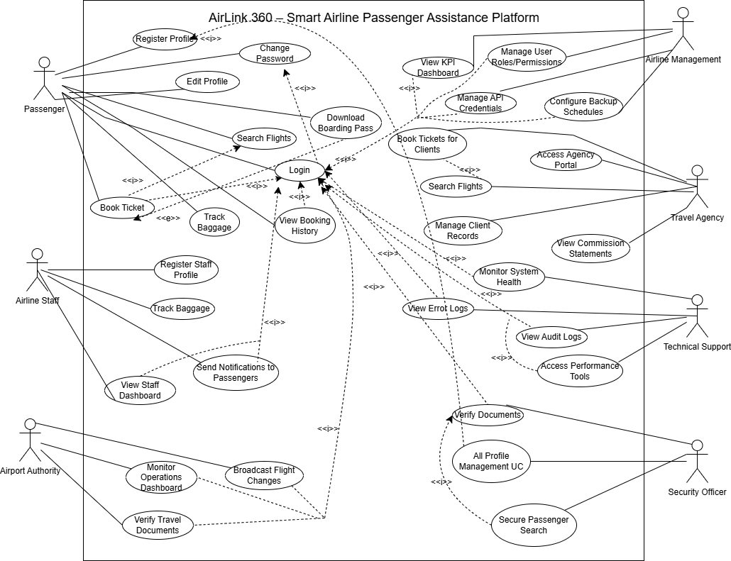

**Figure 1.** Use Case Diagram

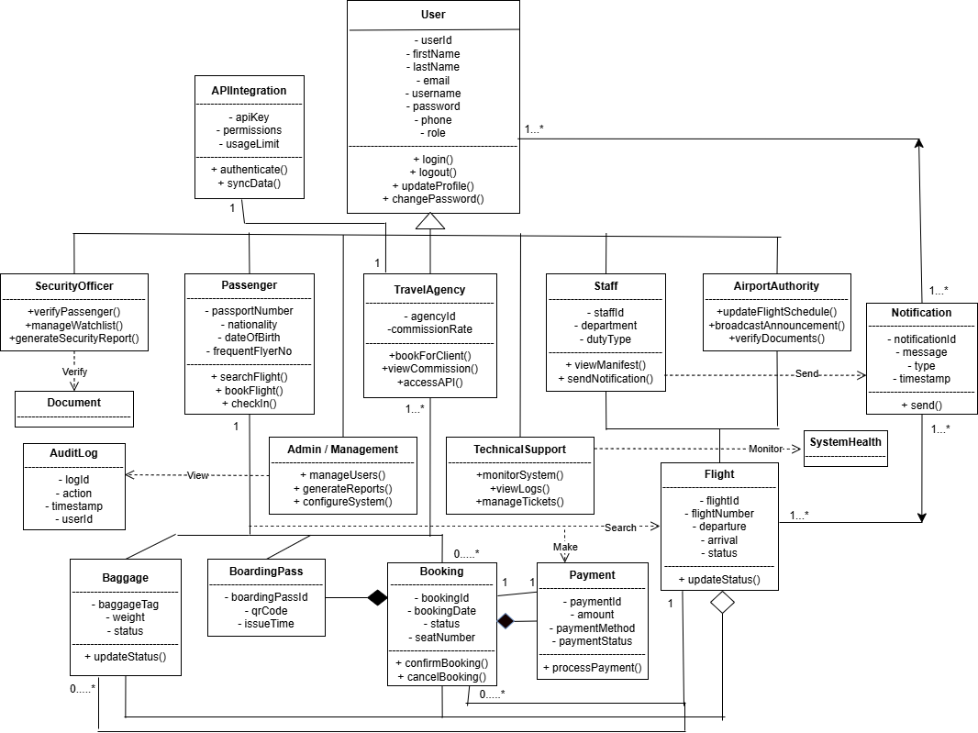

**Figure 2.** Class Diagram

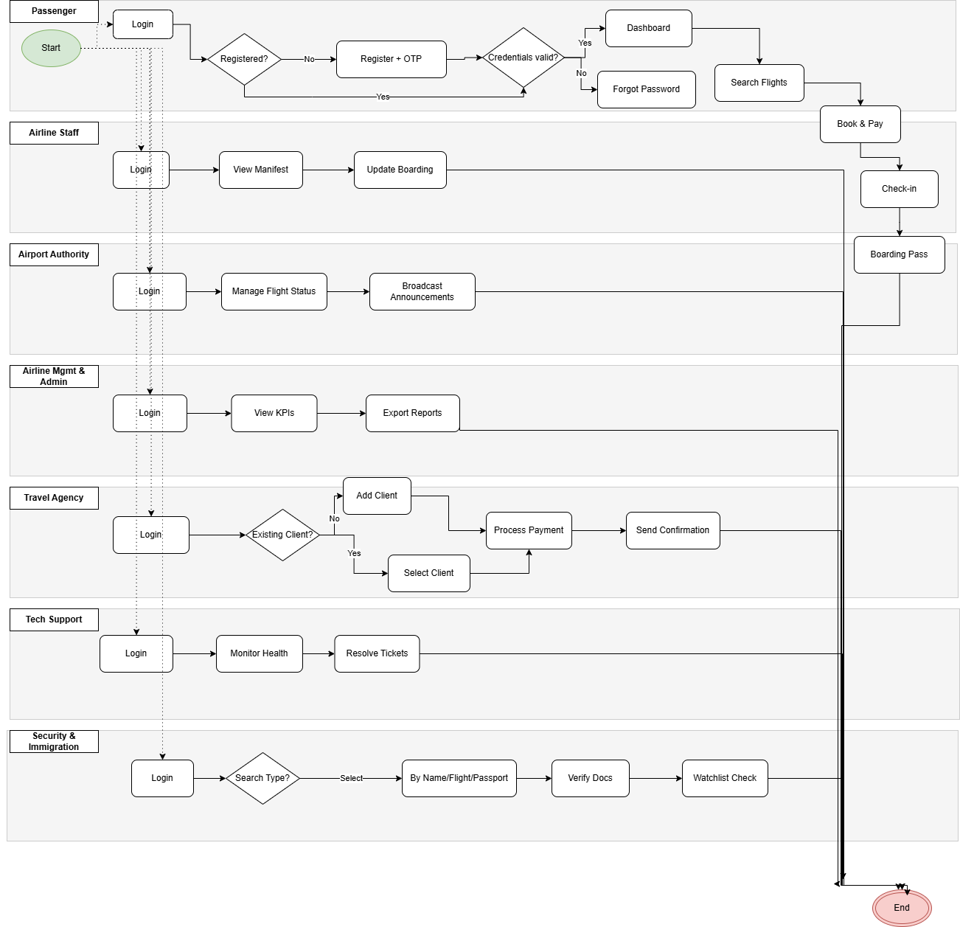

**Figure 3.** Activity Diagram

.

## 3.2UI / Wireframe Design using Figma

System UI Design :

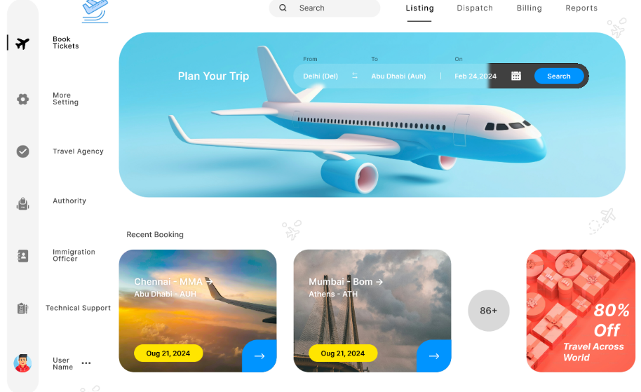

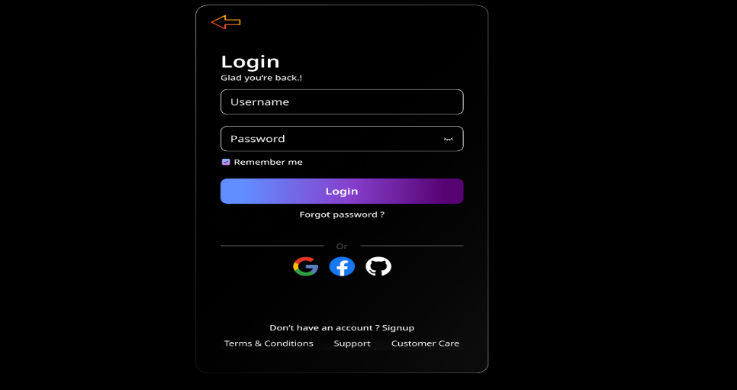

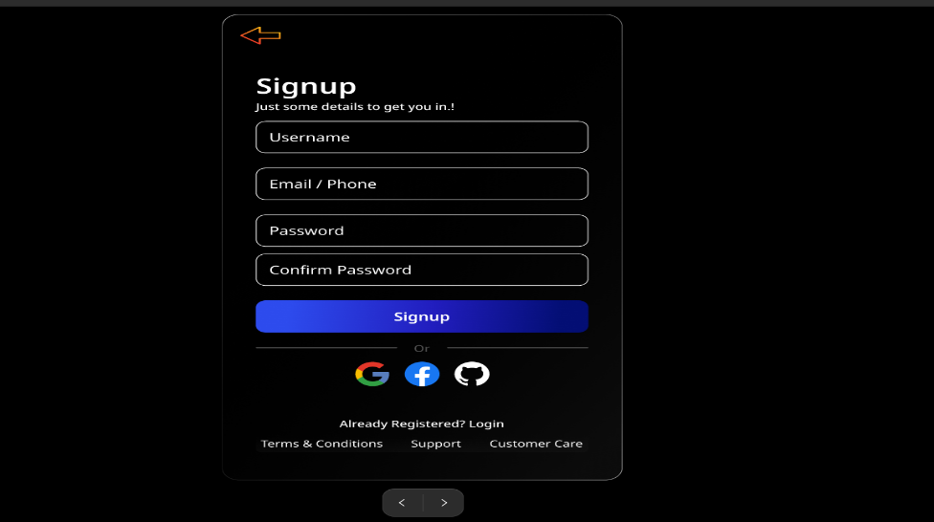

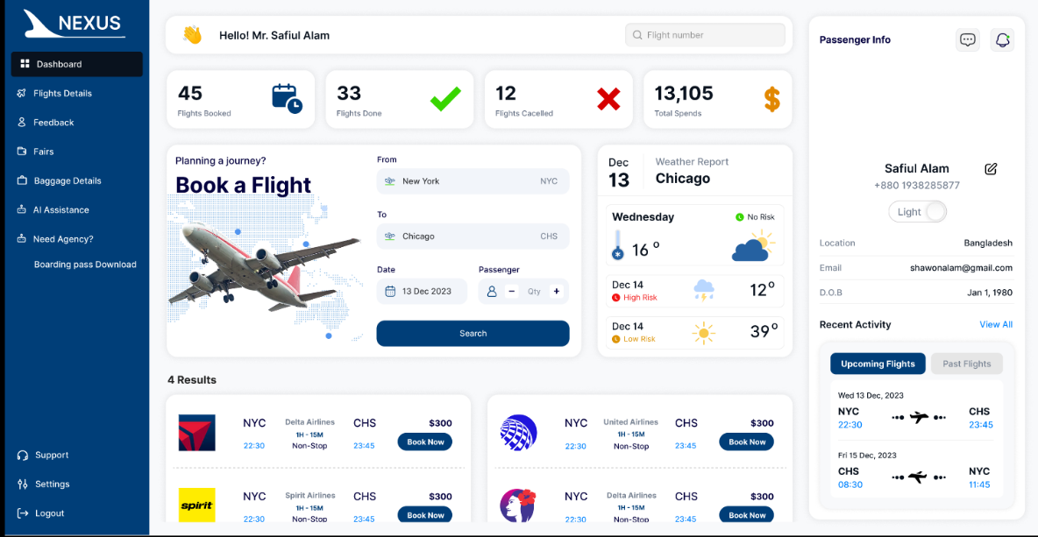

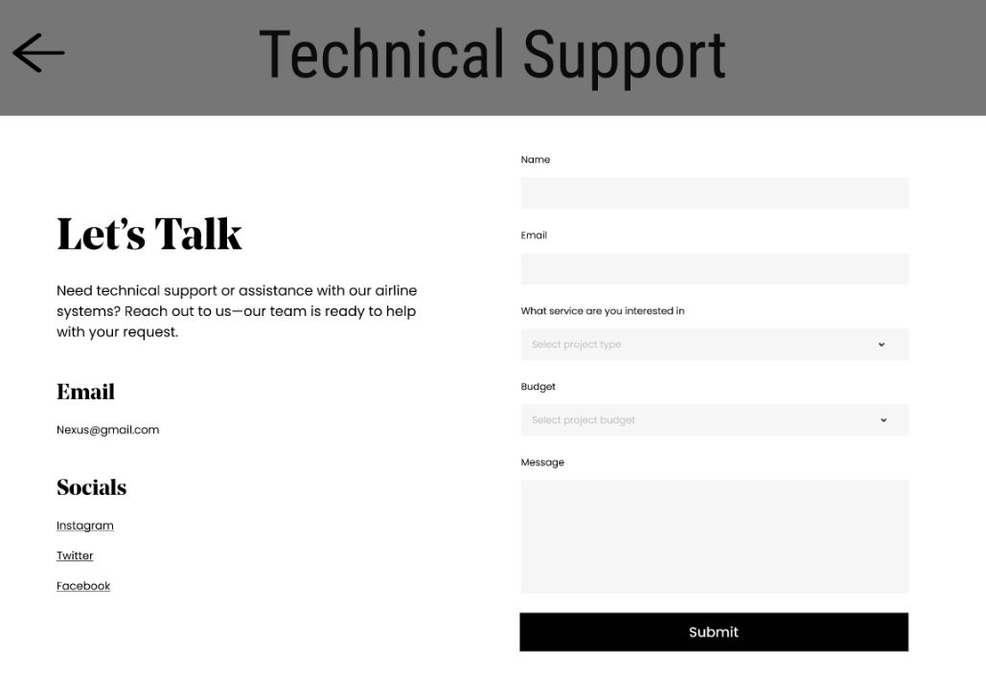

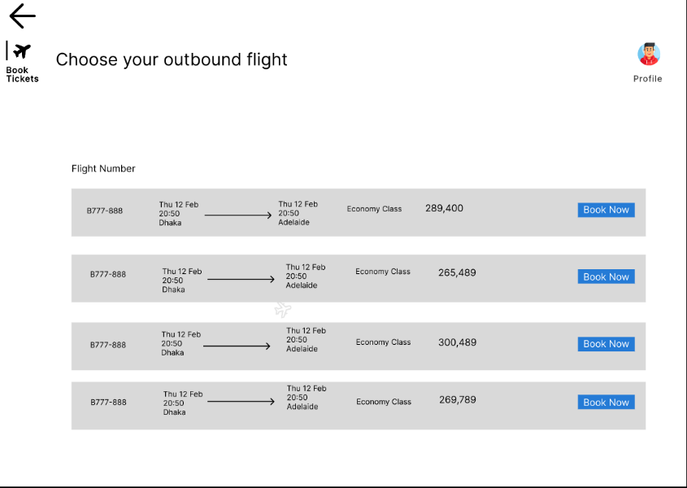

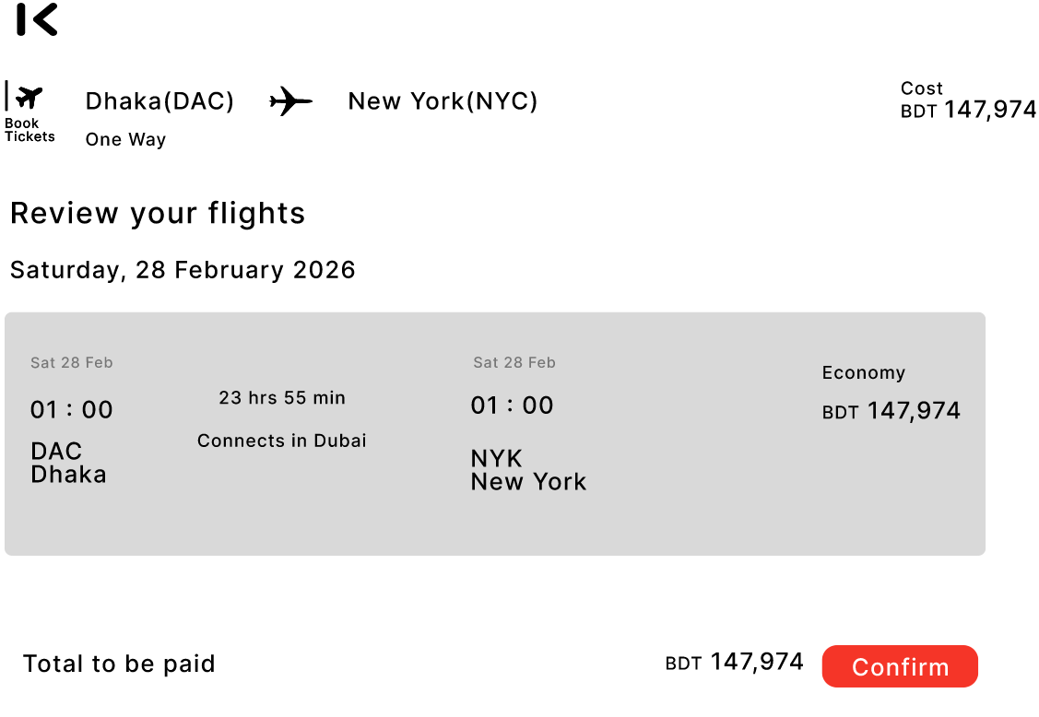

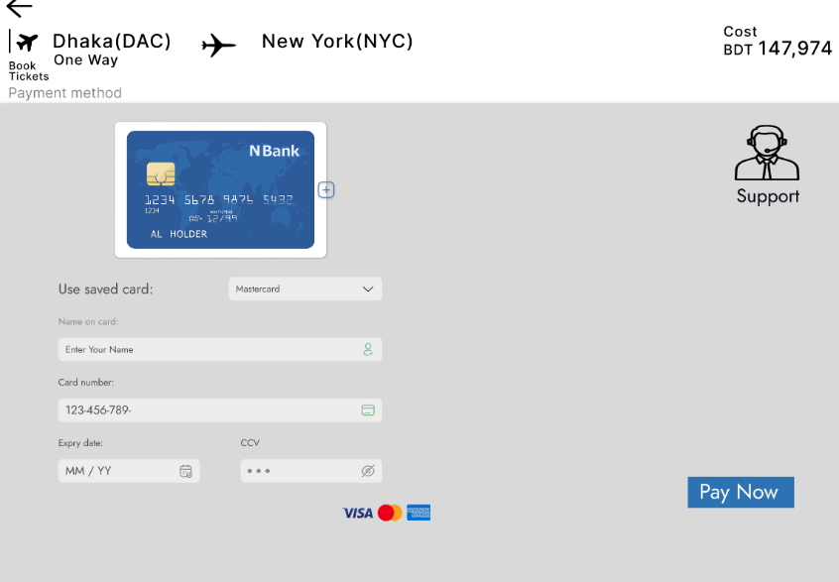

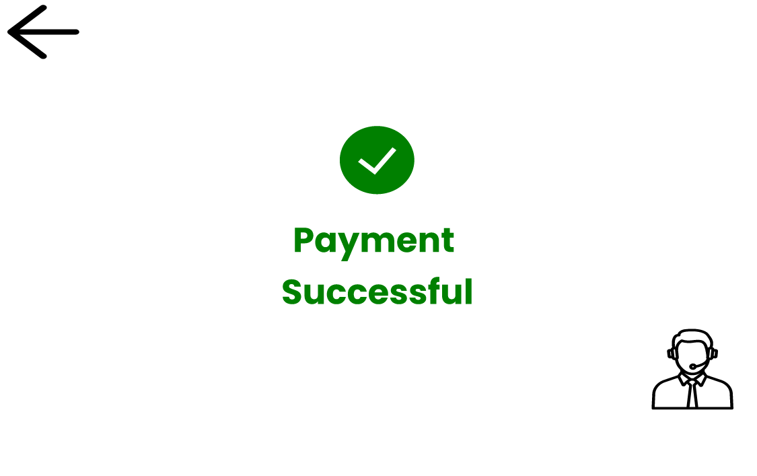

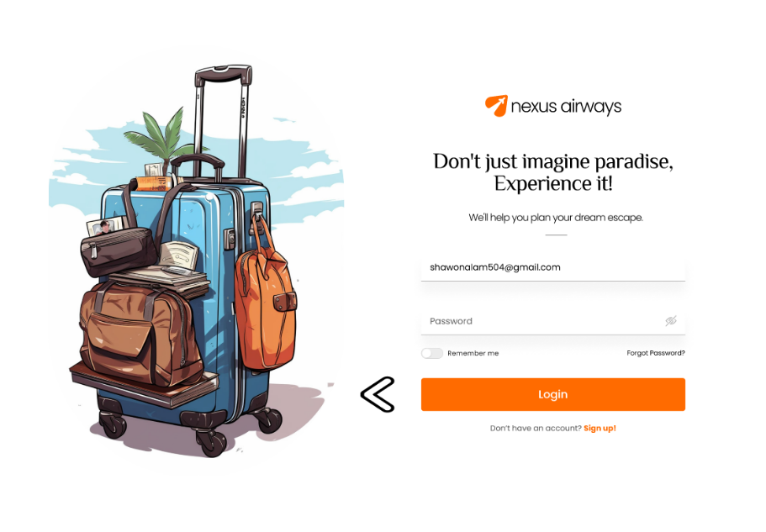

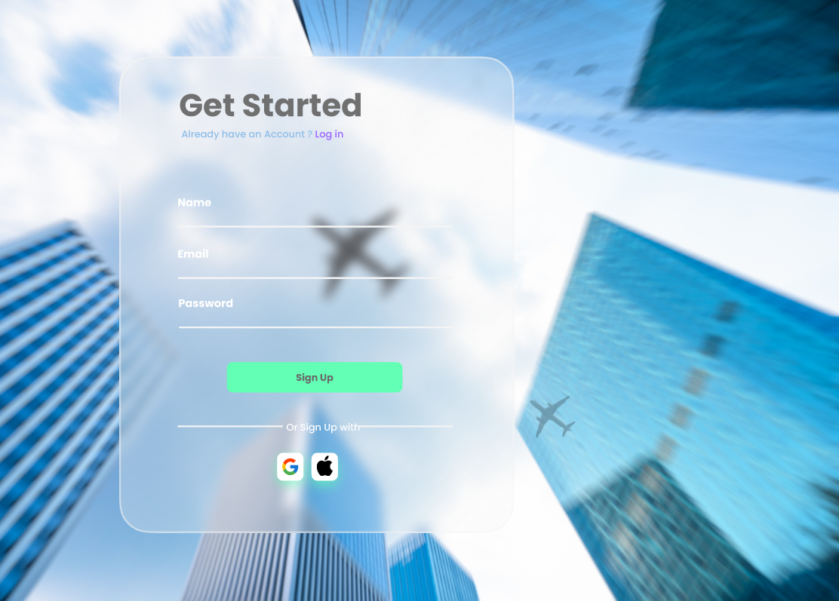

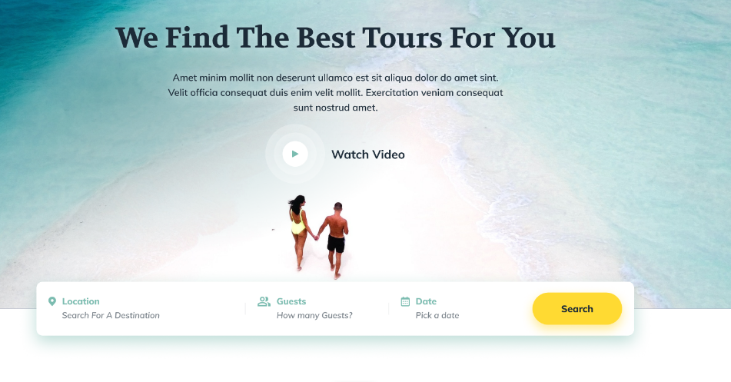

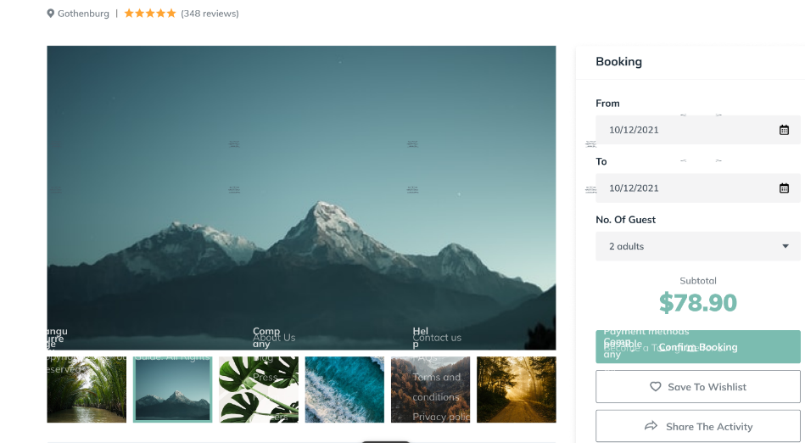

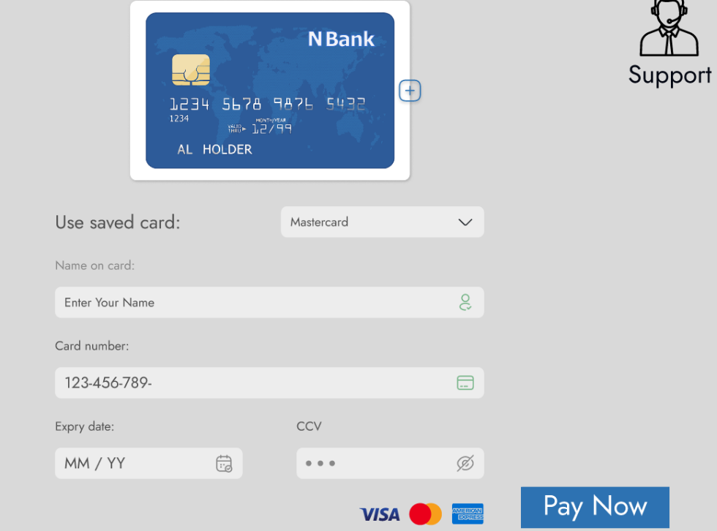

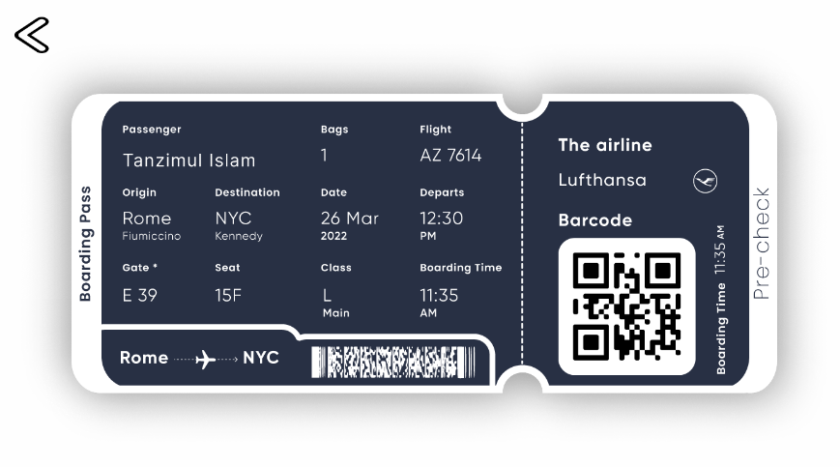



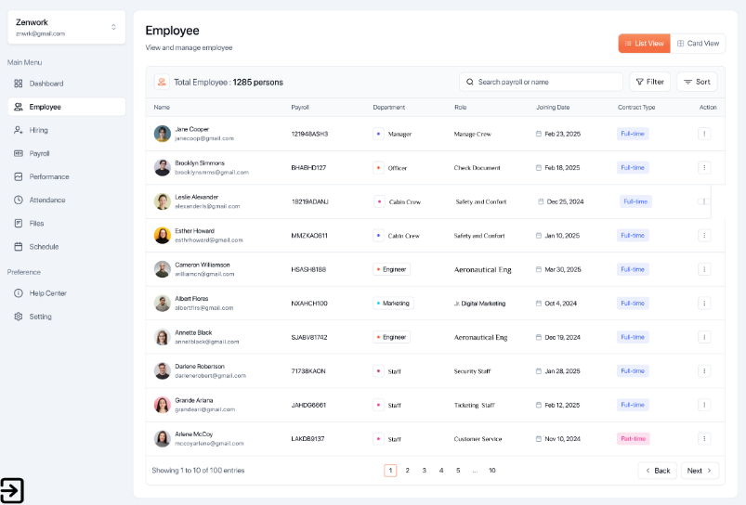

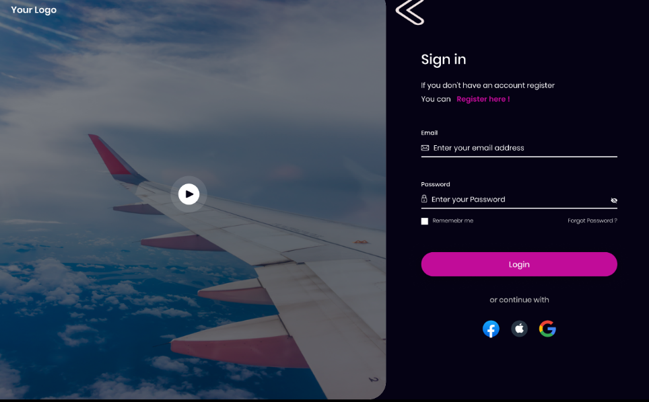

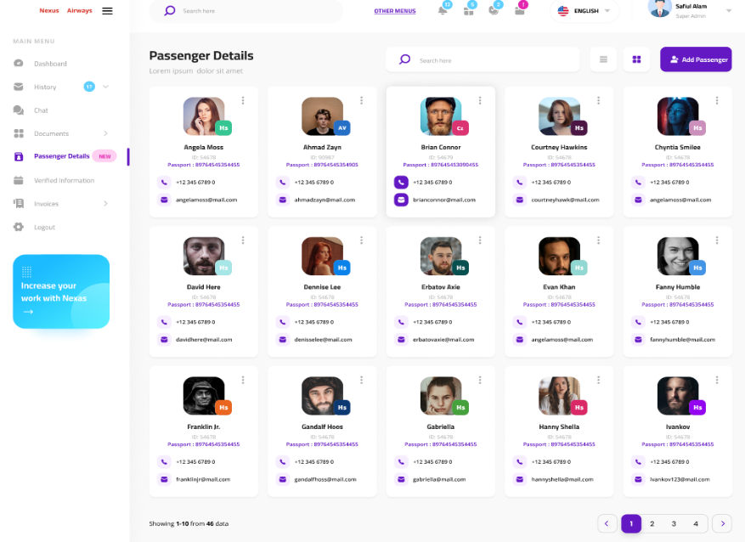

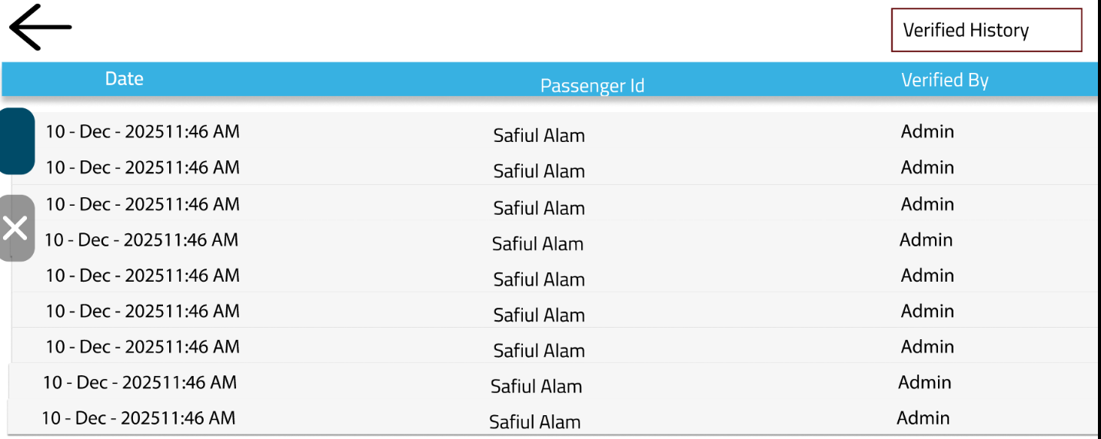

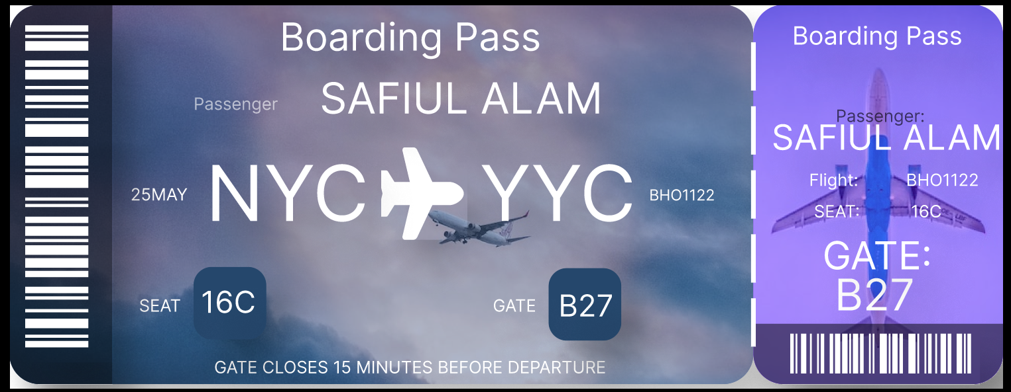

# 4. GIT WORKFLOW

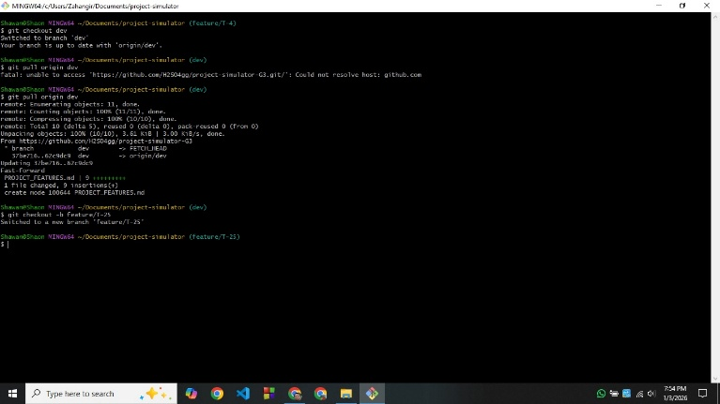

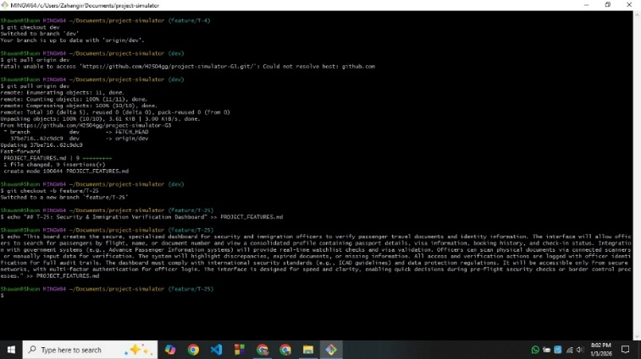

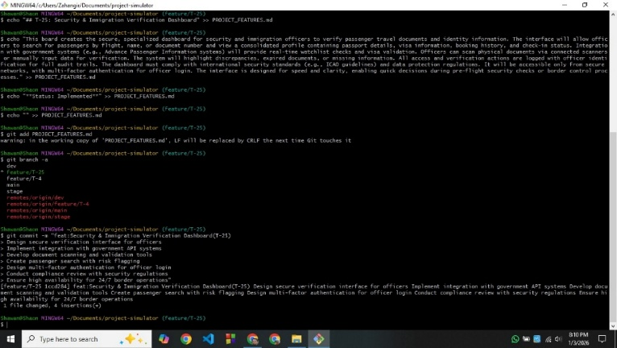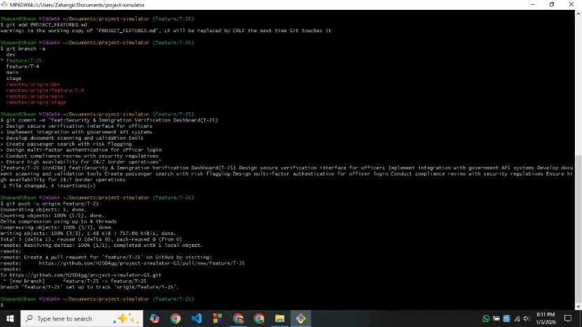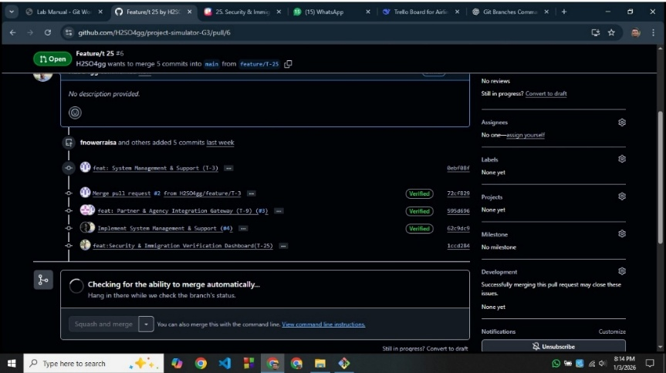

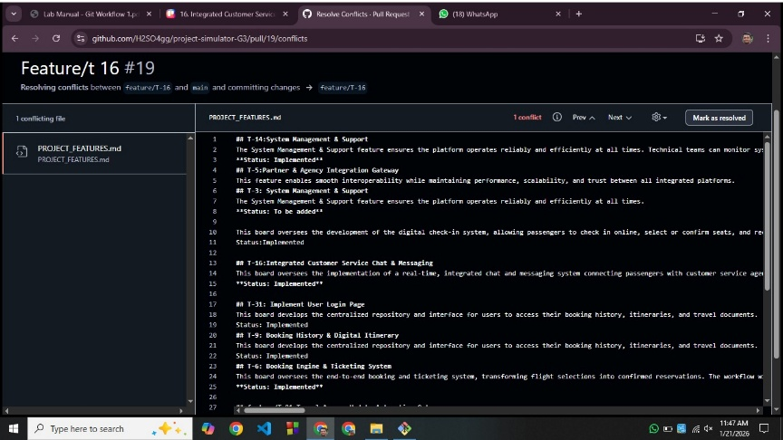

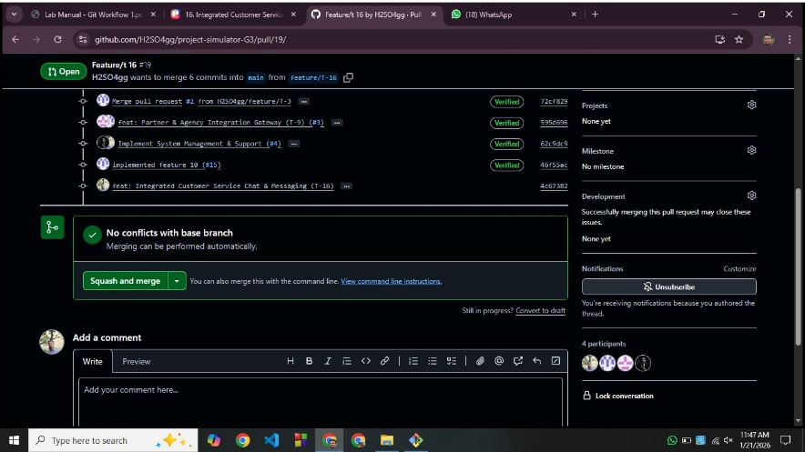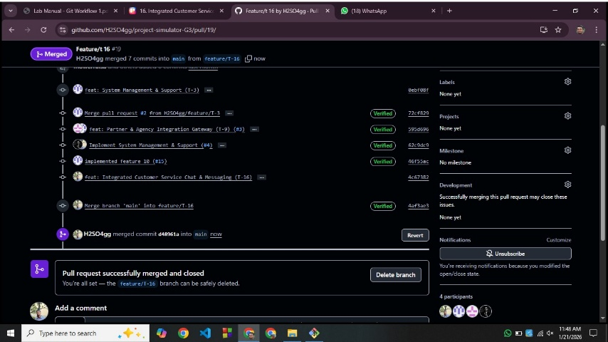

# 5. SOFTWARE TESTING

Since the team has 5 members, each member is responsible for 3 testing types.

The project follows the Scrum model, where development is done in short sprints. Testing is performed continuously in each sprint, not only at the end.

1. **Unit Testing**

Why:

To test individual modules such as login, registration, flight search, booking, and notification components separately.

If Not Done:

Small coding errors may remain hidden and later cause major system failures during integration.

2. **Integration Testing**

Why:

To ensure that different modules (e.g., booking + payment, notification + flight status) work correctly together.

If Not Done:

Data may not pass correctly between modules, causing incorrect bookings, missing notifications, or system crashes.

3. **System Testing**

Why:

To verify the complete system works as expected according to the SRS.

If Not Done:

The final system may not meet project requirements and user expectations.

4**. Functional Testing**

Why:

To confirm all features (login, booking, check-in, baggage tracking, chatbot) function correctly.

If Not Done:

Users may face broken or incomplete features.

5. **Non-Functional Testing**

Why:

To test performance, security, usability, reliability, and scalability.

If Not Done:

The system may be slow, insecure, or difficult to use.

6. **Usability Testing**

Why:

To ensure the system is user-friendly for passengers, staff, and administrators.

If Not Done:

Users may struggle to navigate the system, leading to dissatisfaction.

7**. Performance Testing**

Why:

To check how the system behaves under high load (many users booking or checking flight status).

If Not Done:

The system may become slow or crash during peak usage.

8**. Security Testing**

Why:

To protect sensitive data such as passwords, passport details, and payment information.

If Not Done:

The system may become vulnerable to hacking, data leaks, and unauthorized access.

9. **Regression Testing**

Why:

To ensure new features added in later sprints do not break existing functionalities.

If Not Done:

Previously working features may fail after updates.

10. **User Acceptance Testing (UAT)**

Why:

To confirm the system meets real user needs before final deployment.

If Not Done:

The delivered system may be rejected by users or stakeholders.

11. **API Testing**

Why:

To verify secure and accurate data exchange with travel agencies and partner systems.

If Not Done:

Third-party integrations may fail or return incorrect data.

12. **Compatibility Testing**

Why:

To ensure the system works on different browsers and devices.

If Not Done:

Some users may not be able to access the system properly.

13**. Database Testing**

Why:

To verify correct data storage, retrieval, and consistency.

If Not Done:

Data loss, duplication, or inconsistency may occur.

14. **Smoke Testing**

Why:

To quickly verify that critical features work after each sprint build.

If Not Done:

Faulty builds may move forward into further testing stages.

15. **Exploratory Testing**

Why:

To identify unexpected issues by freely exploring the system.

If Not Done:

Unusual but critical bugs may remain undiscovered.

Relation with Scrum Model

Since Scrum follows an iterative and incremental approach, testing is performed after every sprint.

This helps in:

1.Early bug detection

2.Continuous feedback

3.Improved product quality

|  |  |  |  |  |  |
| --- | --- | --- | --- | --- | --- |
| **Project Name:** Airline Management System | | | Test Designed by : Safiul Alam | | |
| **Test Case ID:** TC_UT_01 | | | Test Designed Date : 15/1/26 | | |
| **Test Priority:** Medium | | | Test Execute by : Safiul Alam | | |
| **Module Name:** Profile Management | | | Test execution date : 16/1/26 | | |
| **Test Title:** Unit Testing | | |  | | |
| **Description:** Test login module independently | | |  | | |
| **Precondition:** User has a valid account | | |  | | |
| Test Steps: | Test Data: | Expected Result: | | Actual Result: | **Status:** |
| • Go to login page  • Enter valid username  • Enter valid password  • Click Login | Username: user01 Password: Pass@123 | User successfully logs in | | As expected | Pass |

|  |  |  |  |  |  |
| --- | --- | --- | --- | --- | --- |
| **Project Name:** Airline Management System | | | Test Designed by : Safiul Alam | | |
| **Test Case ID:** TC_IT_02 | | | Test Designed Date : 15/1/26 | | |
| **Test Priority:** High | | | Test Execute by : Safiul Alam | | |
| **Module Name:** Flight & Booking Management | | | Test execution date : 16/1/26 | | |
| **Test Title:** Integration Testing | | |  | | |
| **Description:** Test integration between booking and payment modules | | |  | | |
| **Precondition:** User is logged in | | |  | | |
| Test Steps: | Test Data: | Expected Result: | | Actual Result: | **Status:** |
| • Search flight  • Select flight  • Proceed to payment  • Complete payment | Card: Valid card details | Booking status becomes Confirmed | | As expected | Pass |

|  |  |  |  |  |  |
| --- | --- | --- | --- | --- | --- |
| **Project Name:** Airline Management System | | | Test Designed by : Safiul Alam | | |
| **Test Case ID:** TC_IT_03 | | | Test Designed Date : 15/1/26 | | |
| **Test Priority:** High | | | Test Execute by : Safiul Alam | | |
| **Module Name:** Complete System | | | Test execution date : 16/1/26 | | |
| **Test Title:** System Testing | | |  | | |
| **Description:** Test complete system workflow | | |  | | |
| **Precondition:** System is deployed | | |  | | |
| Test Steps: | Test Data: | Expected Result: | | Actual Result: | **Status:** |
| • Search flight  • Select flight  • Proceed to payment  • Complete payment | Card: Valid card details | Booking status becomes Confirmed | | As expected | Pass |

4**. Functional Testing**

|  |  |  |  |  |  |
| --- | --- | --- | --- | --- | --- |
| **Project Name:** Airline Management System | | | Test Designed by : Md. Tanzimul Islam | | |
| **Test Case ID:** TC_FT_04 | | | Test Designed date : 06/01/2026 | | |
| **Test Priority:** Medium | | | Test Executed by : Md. Tanzimul Islam | | |
| **Module Name:** Profile Management | | | Test Execution date: 21/10/226 | | |
| **Test Title:** Verify password recovery via email | | |  | | |
| **Description:** Test forgot password functionality | | |  | | |
| **Precondition:** Email is registered | | |  | | |
|  | | |  | | |
|  | | |  | | |
| Test Steps: | Test Data: | Expected Result: | | Actual Result: | Status: |
| 1.Click Forgot Password  2. Enter email  3. Submit request | Email: user@email.com | Reset link sent to email | | As expected | Pass |

5. **Non-Functional Testing**

|  |  |  |  |  |  |
| --- | --- | --- | --- | --- | --- |
| **Project Name:** Airline Management System | | | Test Designed by : Md. Tanzimul Islam | | |
| **Test Case ID:** TC_NFT_05 | | | Test Designed date : 06/01/2026 | | |
| **Test Priority:** High | | | Test Executed by : Md. Tanzimul Islam | | |
| **Module Name:** System Performance | | | Test Execution date: 21/10/226 | | |
| **Test Title:** Verify response time under load | | |  | | |
| **Description:** Test performance under heavy usage | | |  | | |
| **Precondition:** System running | | |  | | |
|  | | |  | | |
|  | | |  | | |
| Test Steps: | Test Data: | Expected Result: | | Actual Result: | Status: |
| 1. Simulate 3000 users  2. Perform flight search | Concurrent users | Response time < 3 seconds | | As expected | Pass |

6. **Usability Testing**

|  |  |  |  |  |  |
| --- | --- | --- | --- | --- | --- |
| **Project Name:** Airline Management System | | | Test Designed by : Md. Tanzimul Islam | | |
| **Test Case ID:** TC_UTY_06 | | | Test Designed date : 06/01/2026 | | |
| **Test Priority:** Medium | | | Test Executed by : Md. Tanzimul Islam | | |
| **Module Name:** Dashboard | | | Test Execution date: 21/10/226 | | |
| **Test Title:** Verify ease of dashboard navigation | | |  | | |
| **Description:** Test user friendliness | | |  | | |
| **Precondition:** User logged in | | |  | | |
|  | | |  | | |
|  | | |  | | |
| Test Steps: | Test Data: | Expected Result: | | Actual Result: | Status: |
| 1. Open dashboard  2. Navigate menu options | Passenger role | User easily navigates dashboard | | As expected | Pass |

|  |  |  |  |  |  |
| --- | --- | --- | --- | --- | --- |
| **Project Name:** Airline Management System | | | **Test Designed By :** IsratJahan | | |
| **Test Case ID : TC_PT_07** | | | **Test Designed date :21/01/26** | | |
| **Test Priority: High** | | | **Test Executed by :Israt JAHAN** | | |
| **Module Name : Notifications** | | | **Test Execution date:** 21/01/26 | | |
| **Test Title : Verify notification delivery time** | | |  | | |
| **Description: Test system speed** | | |  | | |
| **Precondition: Flight delay triggered** | | |  | | |
|  | | |  | | |
|  | | |  | | |
| Test Steps | Test Data | Expected Results | | Actual Results | Status(Pass/Fail) |
| 1.Update flight status  2.send notification | Delay message | Notification received instantly | | As expected | Pass |

|  |  |  |  |  |  |
| --- | --- | --- | --- | --- | --- |
| **Project Name:** Airline Management System | | | **Test Designed By :** IsratJahan | | |
| **Test Case ID : TC_SEC_08** | | | **Test Designed date :21/01/26** | | |
| **Test Priority: High** | | | **Test Executed by :Israt Jahan** | | |
| **Module Name : Profile Management** | | | **Test Execution date:** 21/01/26 | | |
| **Test Title : Verify password encryption** | | |  | | |
| **Description: Test password security** | | |  | | |
| **Precondition: User logged in** | | |  | | |
|  | | |  | | |
|  | | |  | | |
| Test Steps | Test Data | Expected Results | | Actual Results | Status(Pass/Fail) |
| 1.Change password  2.Save changes | New Password | Password securely updated | | As expected | Pass |

|  |  |  |  |  |  |
| --- | --- | --- | --- | --- | --- |
| **Project Name:** Airline Management System | | | **Test Designed By :** IsratJahan | | |
| **Test Case ID : TC_RT_09** | | | **Test Designed date :21/01/26** | | |
| **Test Priority: MEDIUM** | | | **Test Executed by :Israt Jahan** | | |
| **Module Name : Booking History** | | | **Test Execution date:** 21/01/26 | | |
| **Test Title : Verify Booking history after update** | | |  | | |
| **Description: Test Old features after changes** | | |  | | |
| **Precondition: System Updated** | | |  | | |
|  | | |  | | |
|  | | |  | | |
| Test Steps | Test Data | Expected Results | | Actual Results | Status(Pass/Fail) |
| 1. LOG IN  2.Open booking history | Existing Bookings | Old data remains unchanged | | As expected | Pass |

|  |  |  |  |  |  |
| --- | --- | --- | --- | --- | --- |
| **Project Name:** Airline Management System | | | Test Designed by: Fariha Nower Raisa | | |
| Test case ID: TC_10 | | | Test Designed date: 21.01.2026 | | |
| Test Priority: High | | | Test Executed by: Fariha nower | | |
| Module Name: Complete System | | | Test Execution date: 21.01.2026 | | |
| Test Title: Verify system acceptance by users | | |  | | |
| Description: Validate user satisfaction | | |  | | |
| Precondition: System ready for release | | |  | | |
| Dependencies: | | |  | | |
|  | | |  | | |
| Test Steps | Test Data | Expected Results | | Actual results | Status |
| 1. User perform real tasks | Real user inputs | Users approve system | | As expected | Pass |

|  |  |  |  |  |  |
| --- | --- | --- | --- | --- | --- |
| **Project Name:** Airline Management System | | | Test Designed by: Fariha Nower Raisa | | |
| Test case ID: TC_11 | | | Test Designed date: 21.01.2026 | | |
| Test Priority: High | | | Test Executed by: fariha nower | | |
| Module Name: Partner Integration | | | Test Execution date: 21.01.2026 | | |
| Test Title: Verify flight data API response | | |  | | |
| Description: Test API accuracy | | |  | | |
| Precondition: API connected | | |  | | |
|  | | |  | | |
|  | | |  | | |
| Test Steps | Test Data | Expected Results | | Actual results | Status |
| 1. Send API request  2. Receive response | API key | Correct Flight data returned | | As expected | Pass |

|  |  |  |  |  |  |
| --- | --- | --- | --- | --- | --- |
| **Project Name:** Airline Management System | | | Test Designed by: Fariha Nower Raisa | | |
| Test case ID: TC_12 | | | Test Designed date: 21.01.2026 | | |
| Test Priority: Medium | | | Test Executed by: fariha nower | | |
| Module Name: User Interface | | | Test Execution date: 21.01.2026 | | |
| Test Title: Verify system on different browsers | | |  | | |
| Description: Test cross-browser compatibility | | |  | | |
| Precondition: Browsers installed | | |  | | |
|  | | |  | | |
|  | | |  | | |
| Test Steps | Test Data | Expected Results | | Actual results | Status |
| 1. Open system in Chrome  2. Open system in Firefox | Browser types | UI works correctly on all browsers | | As expected | Pass |

|  |  |  |  |  |  |
| --- | --- | --- | --- | --- | --- |
| **Project Name:** Airline Management System | | | Test Designed by : Arfan Nehal | | |
| **Test Case ID:** TC_IT_13 | | | Test Designed Date : 15/1/26 | | |
| **Test Priority:** High | | | Test Execute by : Arfan Nehal | | |
| **Module Name:** Database | | | Test execution date : 16/1/26 | | |
| **Test Title:** Database Testing | | |  | | |
| **Description:** Test database integrity | | |  | | |
| **Precondition:** Booking completed | | |  | | |
| Test Steps: | Test Data: | Expected Result: | | Actual Result: | **Status:** |
| • Book flight  • Verify database entry | Booking details | Correct data stored | | As expected | Pass |

|  |  |  |  |  |  |
| --- | --- | --- | --- | --- | --- |
| **Project Name:** Airline Management System | | | Test Designed by : Arfan Nehal | | |
| **Test Case ID:** TC_IT_14 | | | Test Designed Date : 15/1/26 | | |
| **Test Priority:** High | | | Test Execute by : Arfan Nehal | | |
| **Module Name:** Core System | | | Test execution date : 16/1/26 | | |
| **Test Title:** Smoke Testing | | |  | | |
| **Description:** Verify critical functions after build | | |  | | |
| **Precondition:** Basic system verification | | |  | | |
| Test Steps: | Test Data: | Expected Result: | | Actual Result: | **Status:** |
| • Login  • Search flight | Valid inputs | Core functions work | | As expected | Pass |

|  |  |  |  |  |  |
| --- | --- | --- | --- | --- | --- |
| **Project Name:** Airline Management System | | | Test Designed by: Arfan Nehal | | |
| Test case ID: TC_15 | | | Test Designed date: 21.01.2026 | | |
| Test Priority: Medium | | | Test Executed by: | | |
| Module Name: AI Chatbot | | | Test Execution date: 21.01.2026 | | |
| Test Title: Explore chatbot behavior | | |  | | |
| Description: Identify unexpected issues | | |  | | |
| Precondition: Chatbot active | | |  | | |
|  | | |  | | |
|  | | |  | | |
| Test Steps | Test Data | Expected Results | | Actual results | Status |
| 1. Ask random questions | Free-text queries | Chatbot responds correctly | | As expected | Pass |

# 6. CONCLUSION

In summary, AirLink 360 establishes a cohesive digital ecosystem that seamlessly connects every participant in the air travel journey. By defining clear scopes—from passenger booking and real-time tracking to staff coordination and partner integration, the project ensures that each user group's core needs are met with precision. Passengers gain unprecedented control and transparency through AI assistance and live updates, while airline and airport personnel receive the tools for proactive operations management. Crucially, the platform transcends internal functions by integrating external partners via a secure gateway, extending its reliability to the broader travel industry. This interconnected design eliminates information silos, replacing them with a synchronized flow of data that enhances decision-making, improves service response, and builds trust. The final outcome is not merely a collection of features but a unified experience that streamlines complexity, reduces friction, and elevates the standard for modern, connected air travel for all involved parties.